Facilitating Conservation Planning at Multiple Scales in the Northeast Region
Abstract and Summary of Recommendations
In order to effectively facilitate conservation planning and decision support for partners and stakeholders across the Northeast Region, the North Atlantic LCC needs to ensure that conservation science information and tools are provided and applied at scales and in formats that best meets their needs. As a partnership, we need to agree on and clearly articulate how LCC efforts will be prioritized, organized and integrated around these needs.

The LCC should continue to support an integrated program of information management, science delivery and conservation design that addresses multiple scale and format needs for conservation decision making. The LCC should focus its resources on managing information and facilitating conservation design at larger scales (regional, sub-regional, and landscape) while developing and supporting a partner network to deliver and help partners apply information and tools at more local scales.

Specifically, the LCC should support the following components.
Management of information through Data Basin and LCC websites making regionally consistent information and simple tools easily available for partners and partnerships to access and use. The focus of spatial data and tool development and information management should be on spatial data that is consistently developed across the extent of the Northeast region using a common resolution to allow data sets to be used together to work across scales from regional down to local scales. The Data Basin site and websites should include simple visualization and weighting tools as well as galleries and work spaces for partners working at the regional, sub-regional and landscape scales.

A science delivery program and network that builds on existing partner networks, reaches multiple scales, provides assistance and demonstrates applications of information and tools at those scales. Delivery should include information sessions for conservation decision makers and planners and training and support for agencies, organizations, partners and partnerships that can then train others within their jurisdictions and networks. The focus of these efforts should be at finer scales beyond the direct reach of the LCC including local partnerships, land trusts and municipalities. Delivery should also include demonstration projects focused on application of available science and tools to a range of conservation decisions and scales.

Collaborative conservation designs at regional, sub-regional and landscape scales to both support planning at those scales and apply lessons learned to future efforts. The initial focus at the regional scale should be a collaboration with state fish and wildlife agencies and LCC staff to support the development of regional Conservation Opportunity Areas (COAs) for State Wildlife Action Plans that informs the identification of state-level COAs and potentially becomes part of a national network of ecologically-connected areas. Lessons learned through this process should be applied to future regional conservation designs targeted to broader audiences.

Initial landscape scale conservation designs should be focused on in large watersheds or other similar scale ecoregions where there are active partnerships working. An initial pilot facilitated by the LCC and FWS in the Connecticut River Watershed provides an opportunity for a broad range of partners to learn about both the process and products for landscape scale conservation and apply a systematic approach for linking together landscape change, assessments of ecosystems and species and decision support through conservation design. Similar conservation design efforts in other watershed and landscapes across the region should be encouraged to learn from the Connecticut River Pilot and draw from the same set of tools and information so that they results can be compared across landscapes.

The LCC needs to ensure that these efforts promote learning and dissemination about the process and products so that future conservation design efforts are able to benefit and to prioritize future investments in information and tool development.

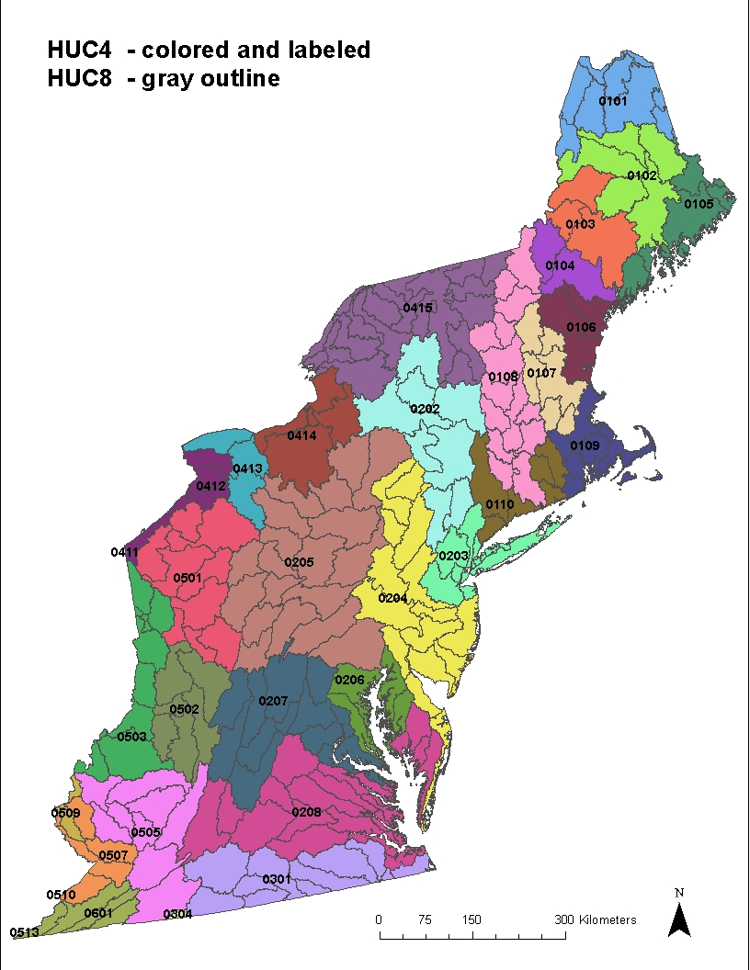
Example of nest scales in the Northeast Region that are important for conservation planning

Problem Statement
In order to effectively facilitate conservation planning and decision support for partners and stakeholders across the Northeast Region, the North Atlantic LCC needs to ensure that conservation science information and tools are provided and applied at scales and in formats that best meets their needs. As a partnership, we need to agree on and clearly articulate how LCC information management, science delivery and conservation design efforts will be prioritized, organized and integrated around these needs at multiple scales and in multiple formats.

Background
LCCs in the Northeast Region provide a forum for federal, state, tribal, university and private partners to collaboratively develop and apply scientific information and tools needed to prioritize and guide more effective conservation actions across the region.

By working together through LCCs, partners can effectively address challenges beyond the capacities and jurisdictions of any one organization and conserve natural resources at spatial and temporal scales that allow them to be more resilient in the face of climate change, land use change and other major threats.
Northeast LCCs recognize and build on the strength of existing conservation partners and partnerships in the Northeast Region. These partners and partnerships have articulated science needs and developed information and tools at various scales and in various formats to address these needs.
This wealth of available conservation science information provides an unprecedented opportunity for collaborative conservation planning but it is also a challenge because of the breadth and complexity of information and the staggered timing of forthcoming results and ongoing planning efforts.
To help organize this information and prioritize future work, the LCCs, Northeast Association of Fish and Wildlife Agencies and other conservation partners in the Northeast agreed upon a regional conservation framework that links together conservation planning, delivery and evaluation. The LCCs use that framework and the resulting strategic plan to guide investments in capacity and projects. Three related components of the framework that have emerged as high priorities for developing, delivering and applying available and emerging information are:
- Information Management: compiling, synthesizing, organizing and making available information, data, science and tools developed by partners and partnerships in scales and formats needed to support conservation planning and decision support;
- Science Delivery: facilitating the delivery and application of science and tools at regional, sub-regional and local scales by working with a network of partners to provide training, translate information to meet specific decision needs, and demonstrating the application of scientific information and tools developed by the LCCs; and
- Conservation Design: developing and integrating information, maps and tools to prioritize where partners need to focus how much of what conservation actions at various scales across the region to achieve natural resource goals and increase resiliency under current and predicted future conditions.
Issues Related to Scales of Conservation
In order to be effective with conservation planning (including the elements of information management, science delivery and conservation design described above), the LCCs and their partners need to ensure that information and tools are available and integrated within and across the geographic scales within which Northeast partners and partnerships are conducting organized conservation planning and delivery.

Scales of planning need not only to consider the scales at which decisions are being made and conservation actions are being taken but also to reflect the most appropriate scales for ecological assessment of various components and patterns of biological diversity and ecosystem function (and the threats and drivers that affect these components and patterns). As these implementation and ecological assessment scales do not always coincide, it is necessary to translate across these scales to ensure the most appropriate information is available to inform decisions.

One effective way to organize and translate among multiple scales of conservation is to consider a hierarchy of scales from the regional down to the site. A nested approach can be defined for administrative or ecological units or some combination. In the Northeast Region different types of hierarchies that are most appropriate to the problem being addressed could be used. Different hierarchies and units with roughly analogous scales are shown in Table 1 and the figure above.

An additional scale-related issue is the resolution the mapped data. For raster data, the resolution relates to the size of the pixels. For most of the raster data used in the Northeast Region, the resolution is 30 square-meter pixels but coarser resolution such as 90 square-meter pixels or thousand acre hexagons are used for some data sets. For polygons and lines the scales vary and may relate to the local or site level extents described above. Several types of data are organized by road-bounded blocks, catchments and other by patches of particular terrestrial, aquatic or coastal habitat types. Although finer resolution is desirable to support many decisions, there may be a limitation of computing power due to the large number of units across the region. For example, there are 734 million 30-meter pixel cells in the region.

Table 1. Hierarchy of Administrative and Ecological Scale Units
Type of Unit | Administrative | Watersheds | Terrestrial Ecological Regions | Coastal/Marine Ecoregions
Scale Extent
Regional | Northeast Region (13 northeast states, could include provinces) | Drainage Area (e.g. Northwest Atlantic) | Bird Conservation Regions, Landscape Conservation Cooperative areas, TNC Ecoregions | Realm: Cold Temperate Northwest Atlantic
Sub-regional | Subregion (e.g. New England or Mid Atlantic states) | Drainage area (e.g. Gulf of Maine, Mid Atlantic, Chesapeake Bay Watershed) | EPA/Omernik Level III, USFS/Bailey Divisions (e.g. Eastern Broadleaf Forest) | Provinces, e.g. Acadian, Virginian
Landscape or State | State or Province | Large watersheds (HUC level 4), e.g. Connecticut River watershed) | EPA/Omernik Level IV USFS/Bailey Provinces | Large Estuaries, e.g. Narragansett Bay
Sub-Landscape or State | County | Tributary sub-watershed (HUC 8) | Major component of a province; e.g. forest, valley or ridge | Small estuary or bay
Local | Municipality | Catchment or HUC 12 | Forest stand or large road-bounded block | Wetland or beach complex
Site | Landholding (e.g. refuge) | Stream reach | Habitat patch or small road-bounded block | Tidal wetland or beach patch

Although state agencies make decisions within their jurisdictional boundaries, northeast state fish and wildlife agencies and coastal zone agencies work collaboratively to address regional priorities. They are thus interested in regional and state scales as well as subunits in their states. Federal agencies and regional or national NGOs typically work across state lines and are often interested in both administrative ad ecological boundaries. Tribes are interested in how tribal lands and tribal rights fit in to larger landscapes. Towns and cities are most interested in land use planning in their municipality but may be willing to incorporate regional, state and landscape scale information to guide open space planning to preserve areas and infrastructure planning to avoid them. In addition to the individual conservation agencies, organizations and tribes in the region, there are multiple conservation partnerships working at and across various scales in the Northeast Region. For example, the Regional Plan Association documented 165 landscape conservation initiatives in the Northeast Region from the local up to the regional scale. For partnerships working at the landscape scale, a plurality of them are associated with various scales of watersheds such as Envision the Susquehanna and the larger Chesapeake Bay Program but there are also partnerships such as Staying Connected that are addressing terrestrial ecoregions (e.g. the northern forest) and species focused partnerships such as the Eastern Brook Trout Joint Venture that are concerned with the entire range of a species.
The challenge for the LCC is to determine what scales and resolutions are best supported by the data, address the appropriate ecological questions for those scales and resolutions and meet decision support needs of partners and stakeholders in the Northeast Region. Integrating results and priorities across scales is also critical. Prioritizing habitats, species or other features at the Northeast scale will have little benefit if the regional perspective is not included in the planning efforts of smaller planning geographies. Conversely, local landscapes will have little integrity if regional priorities are not situated within a network of supporting local habitat features that are supported at that scale.

A final consideration is how the various scales of conservation planning in the Northeast Region will be integrated as seamlessly as possible with adjacent regions. There is interest nationally in having the LCCs play an important role in a national conservation planning including facilitating the habitat conservation strategy of the of the National Fish, Wildlife and Plants Conservation Adaptation Strategy: “Identify areas for an ecologically-connected network of terrestrial, freshwater, coastal, and marine conservation areas that are likely to be resilient to climate change and to support a broad range of fish, wildlife, and plants under changed conditions.” The North Atlantic LCC is coordinating with neighboring LCCs on common approaches for information management and conservation design. There is also a national LCC project to evaluate landscape conservation design approaches in eastern LCCs and identify opportunities for cross-walking them.
Integrated Conservation Planning at Multiple Scales in the Northeast Region
It may not be feasible for the LCC to directly facilitate conservation planning at all relevant scales but by
- making information and simple tools easily available for any partner to access and use;
- supporting a science delivery network that reaches multiple scales, provides assistance and demonstrates applications of information and tools at those scales; and
- facilitating collaborative conservation designs at key scales to both support planning at those scales and apply lessons learned to future efforts;
the LCC will be able to effectively support collaborative and iterative conservation planning in the region. As these conservation planning efforts have not been tried at these scales before, it is critical that they are adaptive and incorporate learning into improving future iterations.

Information Management
As regional-scale landscape conservation partnerships, LCCs should focus on making information, data, science and tools available at scales needed to support regional and landscape scale conservation planning while also assisting partners in utilizing data at other scales.

To the extent possible, the LCCs should provide data that is regionally consistent across their LCC areas and administrative regional scale geographies in and adjacent to their boundaries. For the Northeast region, the North Atlantic LCC is developing and providing data that is consistent across the extent of the North Atlantic LCC area and the Northeast Region recognizing that for states and many other partners, having consistent data within regional and state administrative boundaries is more important than ecological boundaries. For most projects and resulting spatial data, the data are therefore being provided for the full extent of the Northeast administrative region. There are also a limited number of spatial data sets available consistently across the northeast region and the adjacent Canadian provinces of New Brunswick, Nova Scotia, Prince Edward Island and southern Quebec. Additional development of key foundational spatial data across the border should be a priority.

To the extent possible, consistent spatial data that is available at the regional extent and intended for broad application should be developed at a resolution that makes it useful not only at the regional scale but also at finer scales. For raster data, the common currency of most LCC projects is 30 meter pixel resolution that is useful down to but not below the local level. Additional finer resolution data will be needed to supplement regional data at local and site scales.

Based on the results of an extensive information management assessment, the LCC developed an information management system and Conservation Planning Atlas through Data Basin (http://nalcc.databasin.org/) that is open to public for viewing maps and downloading data. Simple tools for visualizing, layering and weighting spatial data layers are being provided. Users with no Geographic Information Systems (GIS) experience are able to use this site and these tools. Those who wish to download individual data layers are able to do that as well. Specific “galleries” of relevant data for partnerships can also be created.

For some partnerships with needs for work spaces with multiple functions (such as posting documents, presentations, discussions and calendars and the ability to download and use multiple spatial data layers), the North Atlantic and Appalachian LCCs have also created nested sites on their LCC websites. The North Atlantic LCC has created a nested site to support the specific data and other needs for State Wildlife Action Plan Updates (http://northatlanticlcc.org/resources/northeast-regional-wildlife-action-plan-synthesis/). The Appalachian LCC has a GIS and conservation planning portal (http://applcc.org/gis-planning). These two LCC websites are linked and can share data across sites.

Science Delivery
Science delivery as defined by the North Atlantic Landscape Conservation Cooperative is broadly defined and relates directly to information management (addressed above) and conservation design (addressed below).

This section will focus on three key parts of science delivery:
- Training in the use of conservation science information and tools for key groups of partners using existing capacity;
- Science delivery partner support through a grant program to promote the use and adoption of LCC landscape conservation science products by using existing and developing new networks to train and provide assistance to others;
- Demonstration projects through a grant program to promote the use and adoption of our landscape science investments by creating examples of on-the-ground applications of landscape conservation science.

Initial direct training is being conducted at two levels. Relatively simple descriptions of the available information and tools are being presented for state and federal agency planners and more detailed technical training and delivery of data focused on State and Federal agency GIS staff. Additional training of other agency and organization staff at these levels should be supported.
Partner support for science delivery is being focused on the multi-state landscape scales and targeted to partners that can access and use existing networks to reach partners that are not directly part of the LCC already such as land trusts and municipalities. Continued support for additional networks across the region is recommended.
Demonstration projects should be targeted to a diversity of scales and audiences and geographic units with the goal of applying information and tools to a specific set of decisions, learning and applying results to other similar audiences and areas across the region.
Conservation Design
One of the key ways that the conservation science information developed in the Northeast Region can be integrated and used for conservation planning to guide decisions by partners is through conservation design. Conservation design is a process for collaboratively agreeing on goals and objectives for a geographic area (typically landscapes) and integrating information, maps and tools to prioritize where partners need to focus how much of what conservation actions to achieve those objectives. More recent conservation design efforts incorporate projected changes due to climate change, land use change and other major drivers. Conservation design products are typically prioritized maps and associated data that show the relative priority of areas in the landscape that translate into focus areas for conservation actions such as land acquisition, ecological restoration or habitat management.

In the Northeast Region there have been a number of state-led conservation design efforts for conservation of biological diversity within state boundaries but very few broader comprehensive landscape conservation design efforts. The focus of the LCC is to help facilitate both regional scale and landscape scale collaborative conservation designs using the best available information that is appropriate to use at those scales. Another key focus is facilitating the ability to inform planning across scales, particularly providing regional and landscape context for state and local actions.
Regional Scale
At the regional scale, the LCC has developed and assembled information that allow for the assessment of priority areas for species, habitat and ecosystems including the consideration of climate change and land use change (urban growth).

Conservation Opportunity Areas
The first effort to assemble this information into a regional conservation design is being taken by the northeast states as part of their effort to develop “Conservation Opportunity Areas” for updates to their State Wildlife Action Plans. The goal is to both develop a regional map of conservation opportunity areas based on importance to Regional Species of Conservation Need and associated habitat types and to inform the development of state-level Conservation Opportunity areas.

Conservation Opportunity Areas (COAs) were first described by the Association of Fish and Wildlife Agencies (AFWA) 2012 in a document titled "Best Practices for State Wildlife Action Plans: Voluntary Guidance to States for Revision and Implementation". Specifically, AFWA recommended that each state: "Identify and spatially depict priority areas on the landscape that offer the best opportunities and potential for Species of Greatest Conservation Need (SGCN) conservation as determined by each state."

Northeast states, the North Atlantic LCC, and the state’s Regional Conservation Need program have worked together to develop a process and invest in science to support the development of foundational data layers and tools with the goal of using that information for COAs. The LCC supported the synthesis of regional information including information on Regional Species of Greatest Conservation Need (RSGCN), the landscape, and the environment so that we can evaluate each species and habitat in the context of the entire Northeast Region.

In order to satisfy the eight required elements of SWAPs, each state must select species most in need, and then identify the location and relative condition of their habitats. The premise of this requirement is that in so doing, actions to conserve species and habitats will be become more efficient, avoiding complicating factors such as high development pressure, poor connectivity, and climate change--and ultimately have a better likelihood of success. Having regional information will help managers make decisions with regional context about the most effective way to distribute their efforts, and how to allocate different conservation approaches, such as land protection and restoration.

Based on meetings with state partners, recommended next steps are to 1) reach concurrence on the objectives served by COAs, and collect input on data, species, or habitats that might need to be incorporated in the process; 2) identify a technical team to serve as a sounding board for detailed technical decisions; 3) provide a document that describes the specific data layers that are available to summarize the relative condition of habitats; 4) collect feedback from GIS and staff scientists in each state on how to select and weight the data layers to best represent their objectives and the relevant measures of the condition of habitats in their state; 5) develop a final recommendation on the technical approach and implement it in the form of a draft spatial data layer or map that can be reviewed in each state; 6) collect input and make revisions as necessary; and 7) in parallel, convene an advisory committee to guide the release of the information and make appropriate decisions about policy implications and communications related to the COAs.

This regional process focused on RSGCNs and their habitats will be a good opportunity to learn about the process and most appropriate products for working at the regional scale. This effort can then be a starting point for future regional conservation design efforts. It may also be a first iteration of a regional map of priority areas that can be part of a national network of ecologically-connected areas as described in the National Fish Wildlife and Plant Conservation Adaptation Strategy.

Landscape Scale
At landscape scales, the LCC and their partners can bring partners and stakeholders together representing a broader set of interests and more local perspective in those landscapes than would be feasible with regional conservation design efforts. It may also be easier to support an ongoing multi-step conservation design effort when meetings are in driving distance for partners. The intermediate scale of large watersheds also allows for prioritizing within a large are but not so large as to make processing models and maps challenging. It is critical that landscape scale efforts be approached in a fairly consistent way utilizing regional information to ensure that regional context and priorities are addressed.

Because of the number of partnerships that are organized around large watersheds and the built in hierarchy of watersheds, the first landscape scale efforts will be in watersheds. The first pilot of a LCC-facilitated landscape scale conservation design effort is taking place in the Connecticut River Watershed.

Connecticut River Watershed Landscape Conservation Design Pilot Project
The Connecticut River Watershed Landscape Conservation Design Pilot Project is a collaborative effort to plan and design a sustainable landscape at the scale of a large watershed. Using the best available science and information, participating partners are developing tools and strategies for conserving a connected network of lands and waters to sustain natural resources and communities within the watershed (Figure 2). The key objectives for the pilot project include the following
- Agreeing on common conservation goals and objectives for the Connecticut River watershed that are informed by watershed and regional priorities (while recognizing social, economic and recreational contributions to future iterations of landscape conservation designs). Initial goals agreed to by the partnership include:
  - The Connecticut River watershed sustains a diverse suite of intact, connected, and resilient ecosystems that provide important ecological functions and services that benefit society, such as clean water, flood protection, and lands for farming, forestry, and recreation.
  - The Connecticut River watershed sustains healthy and diverse populations of fish, wildlife, and plant species for the continuing benefit and enjoyment of the public.
- Delivering information, maps, and tools that show landscape conservation design options for prioritizing conservation actions in the Connecticut River watershed at scales and in formats needed by partners to guide conservation decisions and inform planning; and
- Documenting the process followed, and including lessons-learned, that can be applied to landscape conservation design work in other landscapes across the Northeast.
This pilot is an example of a supported, facilitated, collaborative process using a systematic set of tools that is engaging a broad set of partners at the landscape scale. The support in this case is coming from the North Atlantic LCC staff and the programs and staff of the U.S. Fish and Wildlife Service along with LCC project principal investigators that are contributing information and tools to the design. A core team of about 35 members is meeting monthly for 6-8 months and terrestrial and aquatic sub-teams are meeting more frequently to agree on goals and objectives, learn about the information and tools and use these tools to consider landscape conservation design options for the watershed. The initial focus of this effort is on ecosystems and the services they provide and populations of fish, wildlife, and plants in the watershed including surrogate (representative) species and rare species not represented. The resulting design will be based on weighing and combining the relative value of these features under current and future conditions and at various scales. Because this conservation design is at the landscape scale, it can prioritize locations for conserving ecological systems or habitat for species based on their relative value at the regional, watershed and sub-watershed scale.
Schematic of Connecticut River Watershed Conservation Design Pilot
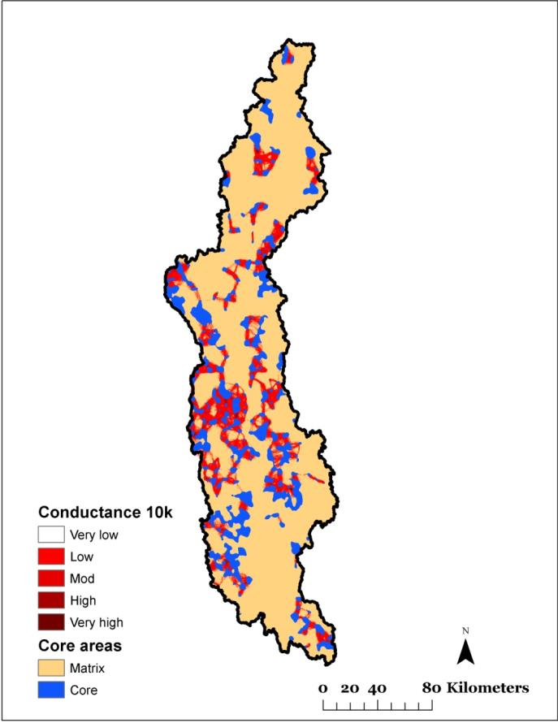

Surrogate Species
Unrepresented Species
Ecological Integrity and Resilience
An interconnected, resilient network of lands and waterways has many benefits for society:
Fish and wildlife populations
Clean water
Flood and erosion control
Storm protection
Forest and farm products
Recreation and tourism
Quality of life
Employment

Other Landscape Scale Conservation Design Efforts
While it is not feasible to provide direct LCC staff and principal investigator support for multiple landscape-scale conservation design efforts at the same time, it is feasible to provide information and training to partners to implement conservation design efforts in their own landscapes. It is critical that the lead partners are well-informed of the tools and information available, use the same regional information and tools, and learn from the Connecticut River Pilot and other efforts that precede their effort. Several partnerships including the Envision the Susquehanna, the Chesapeake Bay Program, the Long Island Sound Study, the Gulf Of Maine Program and the Kennebec River Partnership and others are interested in piloting landscape conservation designs in their geographies. In addition, the National Wildlife Refuge System is interested in using landscape conservation designs to inform all future refuge planning in the region.

Recommendations
LCC staff, principal investigators, and partners need to ensure that products and processes match the scale and format needs of decision makers and use the scale of data most appropriate to answer the ecological questions being asked.

They also need to ensure that products and processes relate across scales so that state and local actions are informed by larger regional and landscape scale priorities.

In order to meet those needs, the LCC should continue to support an integrated program of information management, science delivery and conservation design that addresses multiple scale and format needs for conservation decision making.

The LCC should focus its resources managing information and facilitating conservation design on larger scales (regional, sub-regional, and landscape) while developing and supporting a partner network to deliver and help partners apply this at more local scales.

Specifically, the LCC should continue to support:
- Information management through Data Basin and the LCC websites making regionally consistent information and simple tools easily available for any partner to access and use. Key attributes include:
  - The focus of spatial data and tool development and information management should be on spatial data that is consistently developed across the extent of the Northeast region and where feasible across the North Atlantic LCC area (including adjacent portions of Canadian Provinces);
  - For raster data, a common 30-meter cell resolution should be used to allow data sets to be used together and used across scales from regional down to local scales;
  - Results should be translated to units more feasible for regional analysis such as habitat patches, road-bounded blocks, and hydrologic units;
  - The Data Basin site should include simple visualization and weighting tools that allow potential users to see what spatial data layers look like, how they compare and how they can use these layers to prioritize areas across the region;
  - The LCC should support galleries and work spaces for partners working at the regional, sub-regional and landscape scales including:
    - The nested website for northeast State Wildlife Action Plan Updates;
    - Galleries and work spaces for landscape scale efforts in the Connecticut River Watershed, Chesapeake Bay, Susquehanna River, Gulf of Maine and other landscape-scale geographies where partners are working on conservation design efforts;
  - State or sub-state scale spatial data that is available elsewhere does not need to be on the overall Data Basin site but could be part of specific work spaces;
  - Data Basin and information management websites should link across LCC and regional boundaries;
    - Linkages between the North Atlantic and Appalachian LCC websites should continue to be strengthened;
    - Linkages between the North Atlantic LCC and the Southeast LCC Data Basin sites should be strengthened;
    - Linkages between the LCCs and USGS Climate Science Centers through Data Basin should be evaluated and supported.

- A science delivery program and network that builds on existing partner networks, reaches multiple scales, provides assistance and demonstrates applications of information and tools at those scales. Key attributes include:
  - Information sessions for conservation decision makers and planners to let them know about information and tools available;
  - Training the trainers for agencies, organizations, partners and partnerships that can then train others within their jurisdictions and networks;
    - LCC staff and contractors can provide training to technical staff in agencies, organizations, partners and partnerships;
    - These technical staff along with communications staff can then provide training targeted to specific audiences in their networks;
    - Focus of these efforts should be at finer scales beyond the direct reach of the LCC including local partnerships, land trusts and municipalities;
    - Initial network building should be focused on multi-state networks;
  - Supporting projects that demonstrate the application of information and tools
    - Demonstration projects at multiple scales including multi-state, state, and landscape should be supported;
    - Demonstration projects focused on a range of conservation decisions (land protection, habitat restoration, habitat management, land use planning, streamlining regulatory decision-making) should be supported;
  - Maintaining staff and contractor capacity to implement a program of science delivery.

- Collaborative conservation designs at regional, sub-regional and landscape scales to both support planning at those scales and apply lessons learned to future efforts.
  - The LCC should facilitate conservation planning and design efforts at the Northeast Regional scale
    - The initial focus should be a collaboration with state fish and wildlife agencies with LCC staff support on the development of regional Conservation Opportunity Areas (COAs) for State Wildlife Action Plan Updates;
    - This work should be targeted to Regional Species of Greatest Conservation Need and the terrestrial and aquatic habitat types in the region;
    - The work should be guided by the Northeast Fish and Wildlife Diversity Technical Committee, the State Wildlife Action Planners and state GIS staff with input by other key partner agencies and organizations;
    - The results should not only support the identification of regional COAs but also inform the identification of state-level COAs;
    - The effort should assess the feasibility of using different scale units including 30-meter raster, habitat patches, road-bounded blocks, and hydrologic units;
    - Where feasible, input data and tools should be used at both the regional scale and state and landscape scales to facilitate comparisons across scales;
    - The resulting products should incorporate expected future conditions including climate change;
    - The initial products should be available in time to be used in the current round of State Wildlife Action Plan updates but should be considered iterative to allow for learning and application of additional information and tools as they become available;
    - The regional COAs should be considered for inclusion in a national network of ecologically connected areas for the National Fish, Wildlife and Plants Conservation Adaptation Strategy;
    - Lessons learned through this process should be applied to future regional conservation designs targeted to broader audiences.
  - Landscape scale in large watersheds
    - The initial pilot should be a highly facilitated process in the Connecticut River Watershed with LCC and FWS staff support;
    - This pilot is a chance to learn about both the process (including objective setting) and products for landscape scale conservation;
    - The pilot is an opportunity to apply a systematic approach for linking together landscape change, assessments of ecosystems and species and decision support through conservation design;
    - The pilot should allow for integration and weighting of multiple scales of conservation including regional, landscape (watershed) and sub-landscape;
    - The pilot should allow for integration and weighting of current and predicted future conditions as well as resiliency based appproaches;
    - The pilot should allow for weighting among and between species and ecosystems;
    - The pilot should engage a broad coalition of state and watershed scale partners;
    - The pilot should allow for the inclusion of local data by partners in their geographic areas;
  - Demonstration projects and other watersheds
    - Similar conservation design efforts may be undertaken in other watershed and landscapes across the region in part through demonstration projects supported by the LCC;
    - Although those efforts may be facilitated by other partners, they should be encouraged to learn from the Connecticut River Pilot and draw from the same set of tools and information so that they results can be compared between these landscapes
  - Learning -the LCC need to ensure that these efforts promote learning and dissemination about the process and products so that future efforts are able to benefit.
    - The application of information and tools through these regional and landscape scale designs should inform future investments in information and tool development.
    - These regional and landscape scale efforts should inform each other

Links
LCC Data Basin: http://nalcc.databasin.org/
North Atlantic LCC website/workspace for supporting State Wildlife Action Plans: http://northatlanticlcc.org/resources/northeast-regional-wildlife-action-plan-synthesis
Appalachian LCC GIS and Conservation Planning Portal: http://applcc.org/gis-planning

