
Draft Science Assessment
Last update: 3/07/2012

Table of contents

What is this document?
What does this document not do?
Conservation Priorities
Priorities
Indicators with targets
Current condition of indicators
Terrestrial
Freshwater
Marine
Cultural resources
Current habitat
Terrestrial
Freshwater
Marine
Future Stressors
Climate
Sea level rise
Urban growth
Agricultural change
Invasive species
Energy Development
Conservation Actions
Restore
Maintain
Protect
Future Habitat
Terrestrial
Freshwater
Marine
Other ecosystem services
Future Condition of Indicators
Terrestrial
Freshwater
Marine
Cultural Resources
Conservation Design
Design

What is this document?
The mission of the South Atlantic Landscape Conservation Cooperative is to create a shared blueprint for landscape conservation actions that sustain natural and cultural resources.

The development of the blueprint can be thought of in terms of several key questions:

- What conservation priorities will be used to determine what success looks like and how we will know when we get there?
- What is the current condition of indicators for the SALCC?
- Where is current habitat located?
- How can future stressors (e.g., climate change, urban growth, sea level rise) change habitats?
- How can conservation actions change habitats?
- What will future habitat look like based on future stressors and potential conservation actions?
- What will the future condition of indicators look like based on future habitat changes?
- What conservation design will provide a network of habitats capable of meeting SALCC conservation targets?

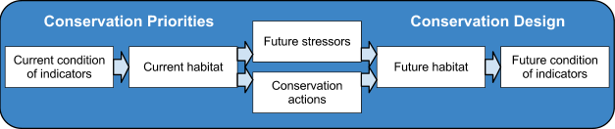

Fig. 1. Flow chart of modeling components for SALCC conservation planning

This science assessment serves as an evolving record of the science used to build this blueprint and the most immediately limiting gaps the cooperative needs to fill to complete the blueprint. The blueprint will cover the entire geography of the South Atlantic LCC, which extends from the southeastern portion of Virginia to northern Florida and covers mostly the Piedmont and Coastal Plain in the Southeastern US. To complete this blueprint, data sources must geospatially cover the entire extent of the SALCC region. Therefore, this assessment focuses only on information that covers the entire SALCC region. This includes both projects that were developed regionally and others that involved integration of information developed at smaller scales to cover the entire SALCC region.

In addition to it’s documentary role, this science assessment serves to provide the entire partnership with an outline of current science progress and immediate needs in order to meet the mission of the SALCC.

Throughout the document you will find two types of information for each modeling component:

- Currently compatible with SALCC conservation planning: These models/data are either currently integrated into SALCC planning models or the staff of the cooperative understands them well enough to formally incorporate them without modification into SALCC planning models. Integrated models or data can take explicit inputs from modeling components and provide output to the next component in the chain (Fig. 1). For example, the National Fish Habitat Action Plan models of fish response are fully integrated because current SALCC planning models feed in predictions of future habitat and can then produce explicit predictions of fish community structure based on that future habitat.

- Most immediately limiting gaps: These information gaps are most immediately limiting to conservation planning at the scale of the entire SALCC. This section is not intended to document all science gaps. It is intended to prioritize filling the most limiting gaps in the entire system (Fig. 1). Therefore, some modeling components will have no major, immediately limiting, gaps. This is particularly true for components like “Current condition of indicators” and “Current habitat” which tend to have more information available than components like “Future stressors” and “Future conditions of indicators” and “Future habitat”.

What does this document not do?

- This document is not intended to be a complete assessment of all available data and models within the SALCC.
- This document does not document all science gaps in the SALCC conservation science planning; it focuses on only those that are most immediately limiting in moving forward in the development of the blueprint.
- This document does not document existing or immediately limiting gaps for monitoring.

Conservation Priorities
What does success look like and how will we know when we get there? While most organizations and partnerships have indicators of success very few have measurable targets for those indicators.

Definitions

Priority: Desired conservation outcome that is difficult to measure (e.g., Ecological Integrity of rivers and streams)

Indicator: A way to measure a priority (e.g., Area of fishable and swimable streams)

Target: A numeric goal for an indicator (e.g., Maintain area of fishable and swimable streams)

Additional examples

Integrity of open pine systems (priority) - Brown-headed Nuthatch (indicator) - Increase coastal plain population by 50% (target)

Integrity of estuarine and marine systems (priority) - Sea grasses collectively (indicator) - Double the area of sea grasses (target)

Cultural sites (priority) - Historic rice fields (indicator) - Maintain area of rice fields in historic condition (target)

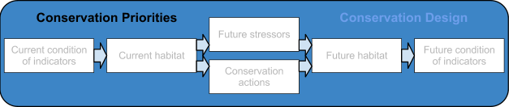

Priorities
Currently compatible with SALCC conservation planning
The partnership defined its initial priorities in the Optimal Conservation Strategies project:

Natural resources: These priorities are based on the integrity of ecological systems
that characterize natural areas and managed landscapes that people care about. Fish
wildlife, and plant populations are both products and indicators of the integrity of these systems.

Ecological integrity: Percent of indicator targets met for:
- Beaches and Dunes
- Caves-Karst Springs
- Estuarine and Marine
- Forested Wetlands (mineral soils)
- Forested Wetlands (organic soils)
- Freshwater aquatic
- Freshwater marshes
- Grassland – Prairie – Savannah
- Southern Pine
- Scrub-shrub
- Upland Hardwood
- Xeric and Maritime Scrub

Viability of threatened and endangered species: It may be necessary to set specific
species targets if improving ecological integrity is not enough

Cultural resources: these priorities are ethnographic; that is, they have a relationship to what people do on the landscape. Examples include huntable and fishable populations of animals, access to public lands, archeological sites and objects. The measurable attributes of these resources are the number, representation of cultures, and value as defined by stakeholders

Cultural sites: Place-based resources, such as buildings, archeological sites, etc. that could
be preserved in situ, restored in situ or moved to other locations for interpretation or
curation

Cultural objects: Items of ethnographic importance that may be preserved, restored, curated
or interpreted in situ.

Biotic cultural resources: Living natural resources or systems that have ethnographic
importance and include areas and populations of importance to hunting and fishing heritage
as well as non harvested populations of public interest

Most immediately limiting gaps
No major gaps that are immediately limiting to planning efforts

Indicators with targets
Currently compatible with SALCC conservation planning
The following are potential indicators with set measurable targets that cover the entire SALCC region and are determined collectively by the conservation community: Birds (Atlantic Coast Joint Venture), Marine fish (South Atlantic Marine Fisheries Council), Endangered species (Recovery plans)

Most immediately limiting gaps
Identify SALCC indicators and measurable targets for those indicators while building on existing planning efforts (e.g., State Wildlife Action Plans, Optimal Conservation Strategies, etc.) and existing measurable targets (e.g., Birds (Atlantic Coast Joint Venture), Marine fish (South Atlantic Marine Fisheries Council), Endangered species (Recovery plans))

Current condition of indicators
What is the current condition of potential indicators? Since specific indicators have not yet been fully developed, sections relating to indicators cover a range of potential indicators. Identifying indicators and measurable conservation targets for those indicators will be a major focus for the SALCC in 2012.

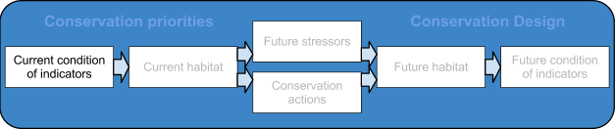

Terrestrial
Currently compatible with SALCC conservation planning
Multiple taxa (La Florida range shift models, Beach nesting species response to sea level rise), Birds (Designing Sustainable Landscapes, Breeding Bird Survey, Integrated Waterbird Monitoring and Management), Herps (SEPARC Priority Amphibian and Reptile Conservation Areas project, SEGAP plus, ARMI, Wildlands habitat connectivity), Mammals (Wildlands habitat connectivity, SEGAP plus), Insect/Plants (Natural Heritage Network), and other species specific models, Historic sites (Protected Areas Database U.S. 1.1 - CBI edition)

Most immediately limiting gaps
No major gaps that are immediately limiting to planning efforts

Freshwater
Currently compatible with SALCC conservation planning
Fish (National fish habitat action plan, MARIS), Herps (SEPARC Priority Amphibian and Reptile Conservation Areas project, SEGAP plus, ARMI), Mussels (Natural Heritage Network), Crayfish (Natural Heritage Network), and other species specific models.

Most immediately limiting gaps
No major gaps that are immediately limiting to planning efforts

Marine
Currently compatible with SALCC conservation planning
South Atlantic Marine Fisheries Council population estimates, Marine Seabird Distribution Models (NCState, Beth Gardner)

Most immediately limiting gaps
No major gaps that are immediately limiting to planning efforts

Other ecosystem services
Currently compatible with SALCC conservation planning
Water quantity (Future flows project), Impact of open space on property values (Habitat benefits toolkit)

Most immediately limiting gaps
No major gaps that are immediately limiting to planning efforts

Cultural resources
Currently compatible with SALCC conservation planning
Swimable and fishable streams (EPA), Landmarks, schools, and churches (US Census Bureau)

Most immediately limiting gaps
Location of historic resources (shell middens, historic rice fields, etc) in areas 3m or less above sea level.

Current habitat
What is the current amount and distribution of habitat types throughout the region?

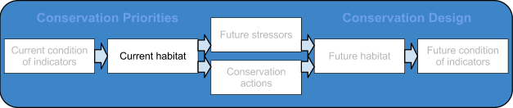

Terrestrial
Currently compatible with SALCC conservation planning
NLCD (2006), Southeast GAP, Protected Areas Database (U.S. 1.1 - CBI edition)

Most immediately limiting gaps
No major gaps that are immediately limiting to planning efforts

Freshwater
Currently compatible with SALCC conservation planning
NLCD (2006), Southeast GAP, Protected Areas Database (U.S. 1.1 - CBI edition), SARP flow alternations and Southeast River Classification, Current daily freshwater flows (unaltered and altered) for NHD+ catchments (Future flows project))

Most immediately limiting gaps
1) Locations of small isolated wetlands not detected by NWI, 2) Locations of small dams and obstructions on rivers and streams

Marine
Currently compatible with SALCC conservation planning
Protected Areas Database (U.S. 1.1 - CBI edition), South Atlantic Marine Fisheries Council habitat data, Data from TNC Marine Spatial Planning project

Most immediately limiting gaps
No major gaps that are immediately limiting to planning efforts

Future Stressors
What stressors are changing the landscape? We live in a time of change where multiple stressors are working to shape the landscape. The more completely we understand those stressors, the better we will be able to predict the way in which those stressors will shape the landscape over the next century.

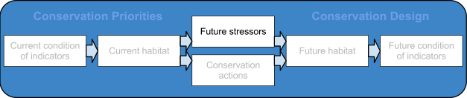

Climate
Currently compatible with SALCC conservation planning
Hayhoe et al. statistically downscaled daily predictions for temperature and precipitation

Most immediately limiting gaps
1) Integration of Hayhoe et al. statistically downscaled predictions with La Florida dynamically downscaled predictions to better represent uncertainty in future temperature and precipitation, 2) Improved precipitation predictions to better represent extremes (Current predictions tend to “flatten” peak rain events)

Sea level rise
Currently compatible with SALCC conservation planning
SLAMM 5 predictions from Designing Sustainable Landscapes project

Most immediately limiting gaps
Improved predictions (including uncertainty estimates) based on seamless LiDAR across the entire South Atlantic region.

Urban growth
Currently compatible with SALCC conservation planning
Sleuth models predicting probability of suburban/exurban at 60m pixels from SERAP project

Most immediately limiting gaps
1) Spatially explicit predictions of the impact of smart growth practices on suburban/exurban development, 2) Incorporation of local and regional long term land use plans, 3) Refinement of models to allow new growth to occur in areas not just adjacent to other development

Agricultural change
Currently compatible with SALCC conservation planning
Regional models (piedmont,coastal plain) models from Southern Forest Futures

Most immediately limiting gaps
Predictions of future changes in non-forest agriculture (i.e., crop and pasture)

Invasive species
Currently compatible with SALCC conservation planning
Terrestrial plants (La Florida exotic plant range shift models)

Most immediately limiting gaps
Future changes in major pathways for species invasions

Energy Development
Currently compatible with SALCC conservation planning
Wind (National Renewable Energy Laboratory Wind Maps), Marine energy (Bureau of Ocean Energy Management/NOAA)

Most immediately limiting gaps
Predictions of future rates and locations for energy development (e.g., wind, biofuels)

Conservation Actions
How can conservation actions change habitats?

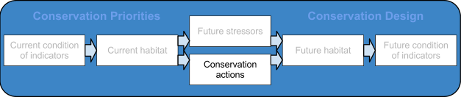

Restore
Currently compatible with SALCC conservation planning
Vegetation Dynamic Development Tool

Most immediately limiting gaps
Predictive models of the impact of hydrologic restoration on natural, cultural, and socioeconomic resources

Maintain
Currently compatible with SALCC conservation planning
Vegetation Dynamic Development Tool , Desired future conditions for southern pine

Most immediately limiting gaps
Estimates of the economic benefits of prescribed fire in open pine (i.e., by maintaining open pine with prescribed fire, how much money is saved by reducing the risk of catastrophic wildfire)

Protect
Currently compatible with SALCC conservation planning
Vegetation Dynamic Development Tool

Most immediately limiting gaps
Predictive model of locations with the greatest opportunity for easements and acquisition based on expert opinion

Future Habitat
What will habitat look like in the future based on stressors and potential conservation actions?

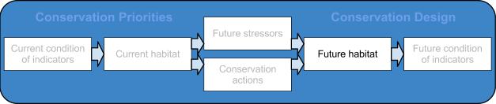

Terrestrial
Currently compatible with SALCC conservation planning
Future landcover based on climate change, urban growth, and sea level rise from sources above (Jennifer Costanza et al, SERAP project), Future tree species distributions

Most immediately limiting gaps
1) Incorporation of vegetation range shifts and agricultural change into future landcover predictions, 2) Impact of mangrove migration on coastal habitat

Freshwater
Currently compatible with SALCC conservation planning
Future daily freshwater flows for NHD+ catchments based on future landcover from above (Future flows project), Nitrogen and Phosphorus loading from Southeast SPARROW models based on future landcover from above.

Most immediately limiting gaps
1) Predictions of future temperature in rivers and streams, 2) Future hydrologic alterations (e.g., dams) due to human population growth and agricultural change

Marine
Currently compatible with SALCC conservation planning
Mangrove migration models (Mike Osland et al)

Most immediately limiting gaps
1) Predictions of future ocean temperature, 2) Impact of future changes in freshwater flow on marine habitat, 3) Impact of mangrove migration on marine habitat, 4) Improved predictions of ocean acidification

Other ecosystem services
Currently compatible with SALCC conservation planning
Water quantity (Future flows project), Impact of change in open space on property values (Habitat benefits toolkit using future landcover from Jennifer Costanza et al - SERAP project)

Most immediately limiting gaps
1) Current carbon sequestration capability / acre / year for South Atlantic habitats, 2) Predictions of current and future water filtration capability

Future Condition of Indicators
How will potential indicators respond to future habitat changes?

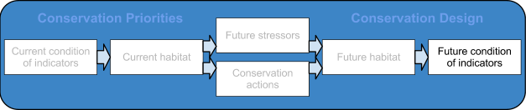

Terrestrial
Currently compatible with SALCC conservation planning
Multiple taxa (La Florida range shift models, Beach nesting species response to sea level rise), Birds (Designing Sustainable Landscapes project, Jaime Collazo et al. Landbird models, Integrated Waterbird Monitoring and Management), Herps (SEPARC Priority Amphibian and Reptile Conservation Areas project, Kyle Barrett et al range shift models, Wildlands habitat connectivity), Mammals (Wildlands habitat connectivity)

Most immediately limiting gaps
Improved range shift models for all taxa (except landbirds) that: 1) Include predictions of uncertainty, 2) Allow for adaptive capacity, 3) Identify potential migration bottlenecks

Freshwater
Currently compatible with SALCC conservation planning
Fish (National fish habitat action plan models using future landcover from Jennifer Costanza et al - SERAP project), Herps (SEPARC Priority Amphibian and Reptile Conservation Areas project)

Most immediately limiting gaps
1) Impact of changes in temperature and flow on fish and mussel communities, 2) Impact of changes in aquatic connectivity on fish and mussel communities

Marine
Currently compatible with SALCC conservation planning
Marine Seabird Distribution Models (NCState, Beth Gardner)

Most immediately limiting gaps
Impact of changes in temperature, flow, and mangrove migration on marine fishes

Cultural Resources
Currently compatible with SALCC conservation planning
none

Most immediately limiting gaps
1) Predictions of future opportunities for outdoor recreation vs. demand, 2) Predictions of changes in swimmable and fishable streams

Conservation Design
What conservation design will provide a network of habitats capable of meeting SALCC conservation targets? Connecting conservation targets, current conditions of indicators, current habitats, future stressors, conservation actions, future habitats, and the future condition of indicators will produce a shared blueprint for landscape conservation actions that sustain natural and cultural resources.

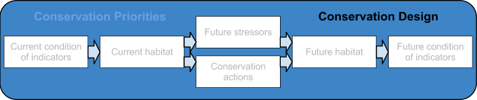

Design
Currently compatible with SALCC conservation planning
Prototype conservation design tools from Optimal Conservation Strategies project

Most immediately limiting gaps
1) Incorporation of ongoing terrestrial and aquatic connectivity analyses into planning models, 2) Sensitivity analysis on the uncertainty in modeling inputs. To which inputs (e.g, climate change, urban growth, habitat response to climate change, etc.) are the models of indicator response most sensitive to changes and thus might result in the biggest change in predicted indicator responses with better information.

