Priority Regional Threat: Pollution

Summary Statement:
All 14 SWAPS cited pollution as a top threat, and together assigned 461 threats to the pollution category. Pollution was also considered as a moderately severe threat that could be addressed with difficulty, offering opportunities for conservation and restoration. SWAPS cited forestry and agricultural effluents and domestic and urban wastewater as the top kinds of pollution, followed by industrial and military effluents.
Many of the Pollution threats in Wildlife Action Plans are associated with aquatic habitats and species. Some severe threats are point sources of toxins including heavy metals, however almost all aquatic habitats and species are impaired and imperiled by non-point sources of nutrients, pesticides, and others. Excess nutrients affect stream water chemistry and influence vegetative growth and exacerbate the confounding threat of invasive species in aquatic habitats and wetlands. Pesticides, including both herbicides and insecticides, can be highly toxic to aquatic organisms and bio-accumulate in the food chain. Other constituents of waste water including endocrine disruptors are an emerging area of concern.

Context
To manage or mitigate pollution threats, conservation planners have long considered how dispersed the source is and classify threats as “point” or “non-point” sources. An additional consideration is whether the pollutant remains mobile or chemically binds to the substrate.
Pollutants of concern in wildlife action plans have both species-specific and habitat-specific targets. Pollutants affect habitats by influencing plant communities (either promoting plants through nutrient enrichment or suppressing plants through herbicides). Pollutants affect species by changing biochemistry or stressing them and making them more susceptible to diseases. Pollutants also affect the food web by reducing populations of invertebrates which are prey for birds, bats, and amphibians.

Results of SWAP Roll-up analysis:
Threats are categorized according to the IUCN classification system in the Northeast SWAP Database. In the Northeast, Pollution threats are primarily related to Waste Water, Industrial and Military Effluents, and Agricultural and Forestry Effluents. Far fewer threats were classified as Garbage and Solid Waste, Air-Borne, or Excess Energy (Fig. 1). There were 217 unique threats associated with species. All taxa are affected, but some of the species with aquatic habitat associations stand out – Fish, Reptiles and Amphibians, and invertebrates. Birds are strong affected by the Industrial and Military Effluents, potentially because, of the SGCN, they are likely to bio-accumulate heavy metals.
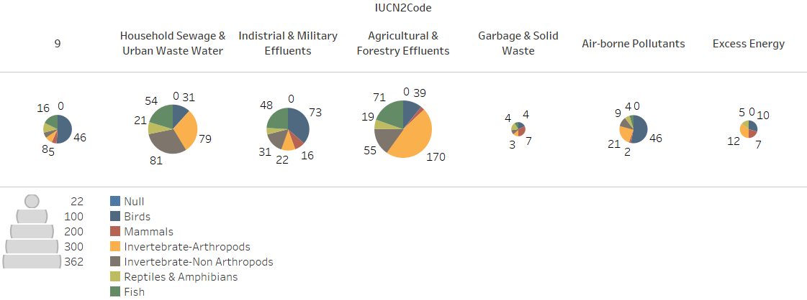
Figure 1. Distribution of SGCN associated with Pollution Threats. Titles across the top represent level 2 threats, except "9" which indicates threats associated with species that were not more specifically coded.
There were 173 unique pollution threats linked to habitats. In general, water-associated habitats like freshwater (streams, rivers, lakes, and ponds), saltwater (estuarine, tidal, marine, and rocky coasts), and wetlands (forested swamps, peatlands, emergent marshes, riparian zones and floodplains, peatlands, wet meadows, shrub marshes, and vernal pools) account for most of the pollution threats (Fig. 2). Terrestrial habitats (forests, grasslands, shrublands, urban areas and other dry land) are significantly less affected by most of the pollution threats with the exception of air-borne pollution which deposits on land and causes a number of concerns.
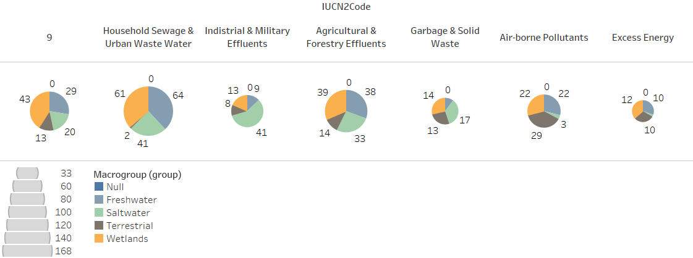
Figure 2. Distribution of habitats associated with Pollution Threats. Titles across the top represent level 2 threats, except "9" which indicates threats associated with species that were not more specifically coded. Pie graphs represent the number of times a habitat of the macrogroup type was associated with the threats in any state WAP.

Table 1. Specific pollutants mentioned in wildlife action plans or personal communications during SWAP Roll-up analysis. (note: please feel free to add to this inventory – and we weren’t sure what key pollutant characteristics would be valuable to include in a table. We had point/non-point in here, but they are almost ALL non-point source problems. Think about how to make this table more useful as a decision-making reference. Severity? Urgency? Irreversibility?):
Pollutant | Mobile or Bound | Target
Nutrients in waste water | N is mobile  P can be bound
Pharmaceuticals and endocrine disruptors in waste water
Chlorine from waste water (ocean impacts at outfall pipes)
Sediment causing siltation or turbidity | Mobile during flooding
Contaminants in impervious surface run-off
Ice-melt chemicals
Nutrients in fertilizer run-off | N is mobile  P can be bound
Nutrients in manure run-off
Herbicides (Round-up)
Insecticides (Neonicotinoids)
Toxins from accidental spills
Regulated chemical discharges
Oil spills
Acidification
Unregulated chemical discharges (coal tar, PCB’s, etc.)
Thermal pollution from power plants
Hydro-fracturing
Lampricide

Actions to address the threat of pollution
A broad range of actions to reduce pollution are proposed in 11 Wildlife Action Plans including Data Collection and Analysis, Law Enforcement, Stakeholder Engagement, Incentives, Direct Management of Natural Resources, Planning, Technical assistance, and Regulations. (Please see associated excel spreadsheet for a comprehensive list of proposed actions.) Actions to address pollution tend to benefit a wide array of species that share the improved habitat, but selecting target species can help determine specific approaches to reduce new pollutant sources or restore currently impaired ecosystems.
Seven states identified Data Collection and Analysis. Questions relate to species’ sensitivity to pollutants like pesticides, heavy metals, and organic compounds. Some actions are linked to habitats, but most are linked to species.
Four states recommended a wide range of Law and Policy actions (VT, RI, PA, NY). For air-bourne pollutant threats which are not bound by watersheds and can be very mobile in the atmosphere, some actions were recommended at a national scale. These aim to reduce acid and mercury contamination in air which is deposited on land. At the state scale actions were directed at protecting aquatic pollution by maintaining water quality standards, strictly regulating pollutants (i.e. discharges, septic system use, runoff), widening buffers along streams, building capacity to respond to accidental spills, reclassifying streams, implementing appropriate fines or penalties for dumping and polluting, and enforcing rules. Many actions were linked to freshwater mussels.
Ten states recommended Partner or Stakeholder Engagement or Incentive Programs to help reduce pollution. Incentives for Riparian buffers were recommended. Incentives to upgrade of Effluent and wastewater treatment facilities or replace failing septic systems were identified as conservation actions. A wide range of education and awareness programs were recommended, particularly concerning the use and effects of pesticides.
Ten states included some Direct Management of Natural Resources. The majority of these proposed actions are categorized as Water Management, Creating New Habitat or Natural Processes, and Vegetation Management. Regarding water management, most states indicate a need to manage stormwater runoff, at all scales and from all kinds of land uses, as an important approach to reducing contamination in streams. Within the Creating New Habitat category, actions tend to address restoration or pollutant management by letting natural processes clear legacy pollution or by recognizing the volatility of legacy pollution and taking care not to re-mobilize pollution that may be bound in sediment and using other stream chemistry constituents to manage the bio-effects of legacy pollutants (for example, pH can affect the uptake of metals). Vegetation management actions are primarily related to enhancing buffers and riparian zones along streams or restoring coastal marshes and estuaries.

Experience:
Try to list prior work in the Northeast Region at the regional Scale to deal with these pollutants. Talk about Chesapeake Bay. Other Initiatives?
Some of our analysis indicates that point-sources are largely regulated effectively with the exception of accidents which can always be better prevented. If true, we may be able to summarize how this was accomplished and some success stories in species recovery. (This is why few of the pollutants in WAPs (Table 1) are point source and most are non-point source.)

Regional Coordinated Actions:
The NEFWDTC has discussed potentially reviewing existing Best Management Practices and (for lack of a better term) ‘endorsing’ them. The committee and states would then help implement these BMP’s by advocating with public and private partners, by motivating the implementation of BMP’s by communicating the wildlife impacts of pollution, or by showing the wildlife benefits of implementing BMP’s.
Would a position paper issued jointly by the states, outlining the vast impacts to SGCN, help engage partners to effectively implement BMP’s?
This is where we will continue to develop the ideas contributed by the group.

